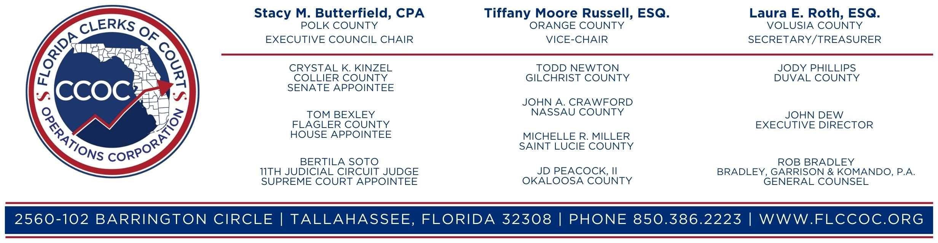

PERFORMANCE IMPROVEMENT AND EFFICIENCIES COMMITTEE MEETING

June 14, 2024

Meeting: 10:00 AM – 12:00 PM, Eastern

Webex Link: <https://flclerks.webex.com/flclerks/j.php?MTID=m9f8f7e2ee2aa7cde3da0bf632b1916b8>

Meeting Number: 2315 646 7652; Password: CCOC

Conference Call: 1-866-469-3239; Access Code: 2315 646 7652

1. Call to Order and Approve Agenda Hon. Laura Roth
2. Approve Minutes from 03/15/24 Meeting Johnny Petit
3. CFY 2023-24 Quarter 2 PMAP Report Johnny Petit
4. Cases/Subcases Update Johnny Petit
5. Payment Plan Workgroup Update Nike Campbell
6. PAC framework/Case Weights Work Group….………………………………Hon. Laura Roth
7. Compliance CPR Training Don Murphy
8. Other Business Hon. Laura Roth

Committee Members: Laura E. Roth, Esq. (Volusia), Chair, Stacy Butterfield, CPA (Polk), Doug Chorvat, Jr. (Hernando), Gary J. Cooney, Esq. (Lake), Brenda D. Forman (Broward), Tara S. Green (Clay), Crystal K. Kinzel (Collier), Michelle R. Miller (St. Lucie), Matt Reynolds (Putnam), Victoria L. Rogers (Hardee), Clayton O. Rooks (Jackson), Angela Vick (Citrus)